Tail dependence: USDCAD and EURGBP
Method 19 / daily log returns / alpha=0.05 / Alpari D1 full available history

Study setup
Logical pair: USDCAD , EURGBP
Broker symbols: USDCAD_i , EURGBP_i
Snapshot: 2026-11-03_majors_alpari_D1
Timeframe: D1
Matched return window: 1999-01-06 to 2026-11-02 (UTC bar dates)
Matched return count n: 7185
Dropped unfinished last bar dated 2026-11-03 UTC after a tick-volume check against the prior complete day.
Uniforms: ranks/(n+1); alpha=0.05
Complete matched rows (Excel): USDCAD-EURGBP_Tail_D1.xlsx
Complete matched rows (HTML table): USDCAD-EURGBP_Tail_D1_data.html

Method carried forward
Tail dependence counts how often both legs sit in an extreme uniform tail together. Matched daily log returns of close, ln(close_t / close_t-1), become u_i = rank(x_i)/(n+1) and v_i = rank(y_i)/(n+1). At alpha=0.05, lower L_hat = (# u<=alpha and v<=alpha) / (# conditioning leg <= alpha); upper uses >= 1-alpha. Both conditioning directions are reported with numerator and denominator counts. Quotes are not inverted. L_hat(0.05) is a finite-sample frequency, not the asymptotic lambda. Same-sample Pearson r is a side check. This is not causation and not a trading signal.

Results
tail | cond | L_hat | num | denom
lower | EURGBP | 0.052925 | 19 | 359
lower | USDCAD | 0.052925 | 19 | 359
upper | EURGBP | 0.144847 | 52 | 359
upper | USDCAD | 0.144847 | 52 | 359
Pearson r on returns: -0.014622

Conclusion
Over 7185 matched daily rows for USDCAD and EURGBP at alpha=0.05, lower L_hat conditioning on EURGBP is 0.0529 (19/359); conditioning on USDCAD is 0.0529. Upper L_hat conditioning on EURGBP is 0.1448; on USDCAD is 0.1448. Pearson r = -0.0146. These are finite-sample frequencies, not asymptotic lambda and not a trading signal.

Charts
Daily closes

Daily log returns

Uniforms with alpha lines
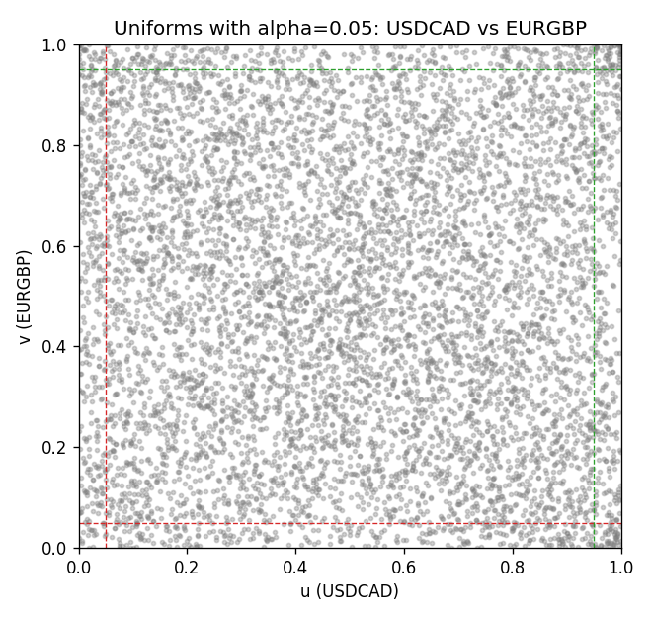

Data report
Every matched row is stored in the sibling Excel workbook named USDCAD-EURGBP_Tail_D1.xlsx, including u and v. Embedding all rows as a Word table is impractical; this file holds column summaries and the first and last 15 matched rows.
Columns: time, USDCAD_open, EURGBP_open, USDCAD_high, EURGBP_high, USDCAD_low, EURGBP_low, USDCAD_close, EURGBP_close, USDCAD_tick_volume, EURGBP_tick_volume, USDCAD_spread, EURGBP_spread, USDCAD_real_volume, EURGBP_real_volume, USDCAD_log_return, EURGBP_log_return, u, v
Column summaries (matched calculation rows)
column | count | mean | std | min | 25% | 50% | 75% | max
USDCAD_open | 7185 | 1.2666594 | 0.16886861 | 0.9168 | 1.1183 | 1.29841 | 1.37203 | 1.6183
EURGBP_open | 7185 | 0.78693389 | 0.09666561 | 0.5734 | 0.6876 | 0.83387 | 0.86521 | 0.9769
USDCAD_high | 7185 | 1.2715589 | 0.16882635 | 0.9336 | 1.1227 | 1.30381 | 1.3764 | 1.619
EURGBP_high | 7185 | 0.79000929 | 0.09704455 | 0.5789 | 0.6896 | 0.8369 | 0.8681 | 0.9799
USDCAD_low | 7185 | 1.2621046 | 0.16891061 | 0.9056 | 1.11396 | 1.29347 | 1.36776 | 1.6102
EURGBP_low | 7185 | 0.78423344 | 0.09648411 | 0.5682 | 0.6855 | 0.83166 | 0.86287 | 0.9661
USDCAD_close | 7185 | 1.2666836 | 0.16885076 | 0.916 | 1.118 | 1.29833 | 1.3723 | 1.6137
EURGBP_close | 7185 | 0.78697576 | 0.09666885 | 0.5735 | 0.6878 | 0.83391 | 0.86533 | 0.977
USDCAD_tick_volume | 7185 | 81049.359 | 147325.09 | 37 | 5563 | 40946 | 71633 | 1410818
EURGBP_tick_volume | 7185 | 87109.869 | 145486.28 | 154 | 6553 | 44326 | 81375 | 1424684
USDCAD_spread | 7185 | 23.430202 | 18.259258 | 0 | 9 | 17 | 40 | 60
EURGBP_spread | 7185 | 21.335421 | 19.123862 | 0 | 4 | 13 | 40 | 50
USDCAD_real_volume | 7185 | 1.8384377e+10 | 9.670755e+10 | 0 | 0 | 0 | 0 | 2.5751613e+12
EURGBP_real_volume | 7185 | 2.7864528e+10 | 1.3519652e+11 | 0 | 0 | 0 | 0 | 3.5726265e+12
USDCAD_log_return | 7185 | -8.08e-06 | 0.00514591 | -0.03859748 | -0.00283484 | 5.597e-05 | 0.00272835 | 0.03436319
EURGBP_log_return | 7185 | 1.874e-05 | 0.00486681 | -0.03067367 | -0.00262366 | -0.00010035 | 0.00255918 | 0.06075387
u | 7185 | 0.5 | 0.28865504 | 0.00013916 | 0.25006958 | 0.5 | 0.74993042 | 0.99986084
v | 7185 | 0.5 | 0.288655 | 0.00013916 | 0.25006958 | 0.5 | 0.74993042 | 0.99986084
First 15 matched rows (selected columns)
time | USDCAD_log_return | EURGBP_log_return | u | v
1999-01-06 | -0.0003306769 | -0.013303338 | 0.46354022 | 0.0080712497
1999-01-07 | 0.0015202092 | 0.011051402 | 0.65126635 | 0.98232675
1999-01-08 | -0.0020495197 | -0.004943862 | 0.30364598 | 0.11925967
1999-01-11 | -0.0035137769 | -0.0012752393 | 0.20762594 | 0.37489563
1999-01-12 | 0.0066194721 | 0.0033970309 | 0.92457556 | 0.80225438
1999-01-13 | 0.0045420214 | 0.00042381861 | 0.85513498 | 0.55023657
1999-01-14 | 0.0069376546 | -0.0019793588 | 0.9316727 | 0.30851656
1999-01-15 | -0.0056905671 | -0.0076715819 | 0.10757028 | 0.048566657
1999-01-18 | 0.00098344542 | 0.00071280921 | 0.596855 | 0.58057334
1999-01-19 | 0.002748513 | -0.0014261269 | 0.75146117 | 0.36181464
1999-01-20 | -0.0059646885 | 0.0019960086 | 0.099081547 | 0.70609519
1999-01-21 | -0.0042823796 | -0.00071240297 | 0.16184247 | 0.43195102
1999-01-22 | 0.0025057712 | -0.0017118406 | 0.73364876 | 0.33217367
1999-01-25 | 0.00085579808 | -0.0054402425 | 0.58488728 | 0.10144726
1999-01-26 | 0.0001973879 | -0.00057438255 | 0.51447259 | 0.44892847
Last 15 matched rows (selected columns)
time | USDCAD_log_return | EURGBP_log_return | u | v
2026-10-13 | -0.0046395653 | 0.00020130374 | 0.14917896 | 0.53061508
2026-10-14 | 0.0015184751 | 0.0011241873 | 0.65112719 | 0.62357362
2026-10-15 | -0.0036101503 | -0.00087557391 | 0.2019204 | 0.41288617
2026-10-16 | -0.0034322068 | -0.0020380844 | 0.21319232 | 0.30336766
2026-10-19 | -0.0018835331 | -0.00056950988 | 0.3179794 | 0.44962427
2026-10-20 | -0.0037066008 | -0.0035906254 | 0.19496243 | 0.18605622
2026-10-21 | -0.00084691787 | -0.00140647 | 0.41344281 | 0.36320623
2026-10-22 | -0.0026307268 | -0.0018743924 | 0.26495964 | 0.31742277
2026-10-23 | 2.85545e-05 | 0.00082421033 | 0.49833009 | 0.59254105
2026-10-26 | 5.7106554e-05 | 0.00013133309 | 0.50027832 | 0.5219872
2026-10-27 | 0.0025379458 | -0.0019957343 | 0.73698859 | 0.30726412
2026-10-28 | -0.0038379274 | 0.00066967224 | 0.18536042 | 0.57737267
2026-10-29 | -0.00011436495 | -0.0011722209 | 0.48371834 | 0.38435847
2026-10-30 | -0.0010298736 | -0.0024205543 | 0.3949346 | 0.26843863
2026-11-02 | 0.00061519094 | 0.00089940465 | 0.56011689 | 0.60089062

